# PROJECTS ON OP AMP

**FIRE ALARM USING OP AMP**

AIM:

To make fire alarm using op-amp.

APPARATUS REQUIRED:

1. Ic-741
2. Buzzler
3. Resistors(10k,10k,220k)
4. Voltage Reguator(20k)
5. Diode
6. Power Supply(Battery 9v)
7. Bread-Board
8. Thermistor

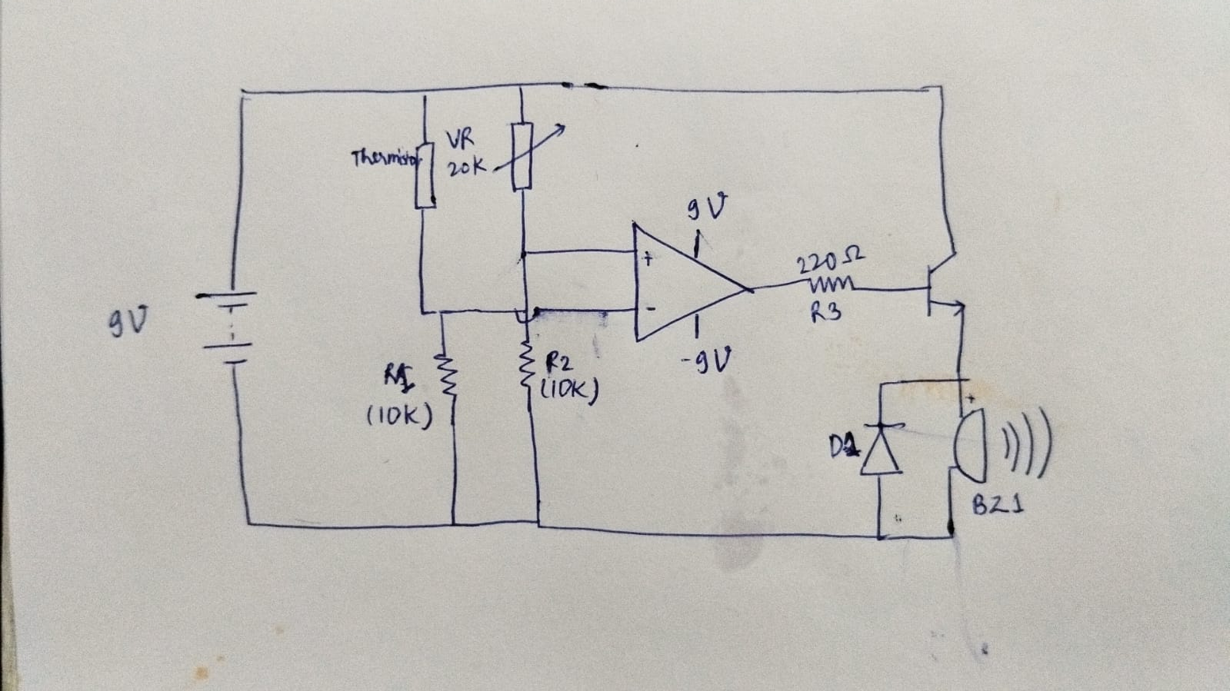

Circuit of FIRE ALARM using op amp

### **Circuit Design**

#### 1. **Sensor Configuration**

* If using a **thermistor**, create a voltage divider. The resistance of the thermistor changes with temperature, providing a voltage proportional to the heat level.

#### 2. **Op-Amp as Comparator**

* Configure the op-amp as a comparator.
* Connect the sensor's output to one input non-inverting of the op-amp.
* Use a potentiometer to set a reference voltage on the other input. This voltage represents the threshold for triggering the alarm.

#### 3. **Output Stage**

* The op-amp's output drives activates the transistor to control a buzzer.
* If the sensor output exceeds the reference voltage, the op-amp's output goes high, triggering the alarm.

### **Circuit Connections**

1. **Thermistor Voltage Divider:**
   * Connect one terminal of the thermistor to the positive supply.
   * Connect the other terminal to a resistor and then to the ground.
   * Measure the voltage at the junction of the thermistor and resistor as the input.
2. **Op-Amp:**
   * Connect the sensor output to the inverting (-) input of the op-amp.
   * Connect the reference voltage (from a potentiometer) to the non-inverting (+) input.
   * Connect the op-amp's output to an LED or the base of a transistor.
3. **Output Device:**
   * For an LED, use a current-limiting resistor in series.
   * For a buzzer, connect it to the collector of an NPN transistor, with the emitter connected to the ground.
4. **Power Supply:**
   * Provide a voltage of 9 volts to the op-amp and other components.

### **Working**

* In normal conditions, the sensor's output voltage is lower than the reference voltage.
* When fire is detected (heat or smoke), the sensor's output exceeds the reference voltage.
* The op-amp output switches to high, activating the alarm (LED/buzzer).
* Adjust the value of the fixed resistor in the thermistor divider to match the sensor's characteristics.

### **Applications**

* Fire alarm systems for homes and offices.
* Industrial safety alarms.
* Heat detection in machinery or equipment.